EduVision_DV
Higher Education Performance Dashboard

Project Documentation & Dashboard Guide

Prepared By- Ankita Mishra
Email- iankitamishra09@gmail.com

September 2026

Executive Summary
EduVision DV is a comprehensive higher-education analytics project that transforms publicly available university ranking data — sourced from the QS World University Rankings and the ARWU / Shanghai World University Rankings — into a unified, interactive Tableau dashboard suite. The project covers the full analytics lifecycle: raw data collection, cleaning and standardization, KPI engineering, dashboard design, and integration into a single navigable workbook.
The final deliverable, EduVision_DV.twbx, consists of four interconnected dashboards — University Overview, Research Analytics, Student Analytics, and Country Comparison — that allow students, researchers, university administrators, policymakers, and education consultants to explore institutional performance, benchmark countries, and identify global trends in higher education.
This document explains the end-to-end project workflow, the data cleaning and KPI engineering methodology, and walks through each of the four dashboards individually, describing the visuals, filters, and the insights each one is designed to surface.

Document Contents
- Project background, objectives, and intended audience
- End-to-end project workflow across four milestones
- Data collection and cleaning methodology
- Education KPI engineering — definitions and formulas
- Individual walkthrough of all four dashboards, with screenshots
- Evaluation criteria, tech stack, and final deliverables

1. Project Overview

1.1 Project Statement
This project develops a comprehensive higher education analytics dashboard suite for analyzing university rankings, research performance, student diversity, academic excellence, and global education trends. Using publicly available datasets — the QS World University Rankings and the ARWU (Shanghai) World University Rankings — raw educational data is transformed into actionable insights through a set of interactive Tableau dashboards.
The dashboard suite is designed to enable five primary audiences to evaluate institutional performance, compare universities globally, analyze research output, and identify trends in higher education:
- Prospective students researching and comparing institutions
- Academic researchers analyzing global research productivity
- University administrators benchmarking their institution against peers
- Policymakers assessing national higher-education performance
- Education consultants advising clients on institutional strategy

1.2 Final Deliverable
The final deliverable is a single, unified Tableau workbook (EduVision_DV.twbx) consisting of four interconnected dashboards, each accessible through a shared top navigation bar and linked by global filters and parameter actions:
- University Overview
- Research Analytics
- Student Analytics
- Country Comparison

1.3 Project Outcomes
- Collection and integration of global university datasets
- Data cleaning and transformation for educational analytics
- Development of six higher-education KPIs
- Creation of four interactive Tableau dashboards
- University ranking and performance analysis
- Country-level education benchmarking
- Interactive filters and drill-down capabilities across the workbook
- A single Tableau workbook (.twbx) as the final, portfolio-ready deliverable

2. Project Workflow
The project followed a linear, seven-stage analytics pipeline, moving from raw data collection through to a fully integrated and tested dashboard suite. Each stage produced a concrete deliverable that fed directly into the next stage, ensuring traceability from the original ranking sources through to the final Tableau workbook.

2.1 Workflow Diagram
1 | Collect University Datasets
2 | Data Cleaning & Transformation
3 | Education KPI Engineering
4 | Dashboard Development
5 | Dashboard Integration
6 | Testing & Validation
7 | Documentation & Delivery
Figure 2.1 — The seven-stage EduVision DV workflow, from raw data collection to final documentation and delivery.

2.2 Milestone Structure
The workflow above was organized into four two-week milestones, each with its own tasks, deliverables, and evaluation criteria, summarized in Section 8 (Evaluation Criteria).
Milestone | Weeks | Focus
1 — Data Collection & Preparation | 1–2 | Collect QS & ARWU datasets, merge into a common structure, clean and standardize
2 — KPI Engineering & Planning | 3–4 | Calculate the six education KPIs; design and prototype dashboard layouts
3 — Dashboard Development | 5–6 | Build all four dashboards and integrate them with shared filters and navigation
4 — Testing & Delivery | 7–8 | Validate KPI accuracy, test interactions, document and deliver the workbook

3. Data Collection & Cleaning

3.1 Module 1 — University Data Collection
The raw data collection stage merged two independent global ranking systems into a single common structure, university_raw_data.csv (1,501 institution records). The tasks performed were:
- Downloading the QS World University Rankings dataset
- Downloading the ARWU / Shanghai World University Rankings dataset
- Collecting supporting university performance indicators (faculty ratios, international scores, research sub-scores)
- Merging both ranking datasets into a common institution-level structure keyed on institution name, country, and region
Evaluation target: successful dataset integration with completeness above 95%. This target was met, with the merged raw file carrying 38 columns spanning identity fields (institution name, country, region, size, focus), QS sub-scores, ARWU sub-scores, and rank fields for both systems.

3.2 Module 2 — Data Cleaning & Transformation
The cleaning stage is documented step-by-step in education_cleaning.ipynb and produced the Tableau-ready deliverable university_cleaned.csv (1,492 rows, 36 columns). The notebook follows a 25-step process across two milestones; the key data-quality operations were:
- Standardizing column names to a consistent snake_case convention (e.g. "AR SCORE" → academic_reputation_score)
- Cleaning the institution name column (removing parenthetical abbreviations such as "(MIT)")
- Removing duplicate institution records
- Converting text-based rank fields (with symbols such as "7=" for tied ranks) into clean numeric ranking columns for both QS and ARWU
- Deliberately not blanket-filling missing Shanghai/ARWU ranks, since a large share of institutions are legitimately unranked by ARWU rather than missing data
- Creating ranking-band categories (e.g. Top 10, Nov-50, 51-100, 101-500, Unranked) for both ranking systems
- Computing the rank difference and an absolute rank difference between the QS and ARWU systems, to flag institutions where the two rankings diverge
- Standardizing country names for consistent geographic joins and mapping
Evaluation target: less than 2% missing values across the fields used for KPI calculation and dashboard visuals — met, with the final cleaned dataset validated at the end of the notebook (Milestone 1 final validation, Step 15) before being saved as the Milestone 1 deliverable.

4. Education KPI Engineering
Module 3 — implemented in generate_education_kpis.py — takes the cleaned wide-format dataset and produces the Tableau-ready university_final_dataset.xlsx by validating five KPIs that already exist as QS sub-scores in the cleaned data, and calculating one derived KPI from ARWU sub-scores. All six KPIs are scored on a common 0–100 scale, which allows them to be compared and blended directly inside Tableau.
# | KPI | Source Column | Definition
1 | Global Ranking Score | global_ranking_score | QS overall ranking score, normalized to a 0–100 scale
2 | Academic Reputation Score | academic_reputation_score | QS Academic Reputation survey score
3 | Faculty-to-Student Ratio Score | faculty_student_ratio_score | QS Faculty/Student Ratio score
4 | International Student % Score | international_student_score | QS International Students Ratio score
5 | Research Impact Score | research_impact_score | QS Citations-per-Faculty score
6 | Research Productivity Index | research_productivity_score | Calculated — average of 3 ARWU sub-scores (see 4.1)

4.1 KPI 6 — Research Productivity Index (calculated)
The only KPI that required a calculation rather than direct use of an existing QS score is the Research Productivity Index. It is derived as the row-wise average of three ARWU research-output sub-scores, deliberately combining volume, influence, and prestige into a single blended measure:
research_productivity_score = mean( arwu_publications_score, arwu_highly_cited_researchers_score, arwu_nature_and_science_score )
- arwu_publications_score — a measure of overall research volume (total papers indexed)
- arwu_highly_cited_researchers_score — a measure of research influence, based on the number of highly-cited researchers on faculty
- arwu_nature_and_science_score — a measure of top-tier research output, based on papers published in Nature and Science
The script validates that the average KPI completeness across all six columns exceeds the 95% target before exporting the final workbook, and prints a per-column missing-value report for transparency.

4.2 Validation & Export
generate_education_kpis.py performs three checks before export: it asserts that each of the five pre-existing KPI columns is present in the cleaned dataset, it recomputes the Research Productivity Index from the three ARWU sub-scores, and it calculates overall KPI completeness across all six KPI columns. On passing validation, the script exports university_final_dataset.xlsx — the file used as the Tableau data source for all four dashboards.

5. Dashboard Suite Walkthrough
5.1 Navigating the Workbook
All four dashboards are wrapped inside a single Tableau workbook and share a consistent navigation and interaction model, so a viewer never has to relearn the interface when moving between them.
- Top navigation bar — Each dashboard opens with four large tab-style buttons across the top: University Overview, Research Analytics, Student Analytics, and Country Comparison. Clicking any tab acts as a navigation (sheet-swap) action that instantly switches the active dashboard while preserving the current filter state, so a comparison a viewer sets up on one tab carries through to the next.
- Active-tab highlighting — The tab corresponding to the dashboard currently on screen is visually distinguished (bordered/shaded) from the other three, giving the viewer a constant sense of "where am I" as they move through the workbook.
- Consistent page anatomy — Every dashboard follows the same top-to-bottom layout: navigation bar → filter/parameter row → KPI summary cards → a grid of supporting charts. This repetition means a viewer only has to learn the layout once.
- Colour language — Region colour-coding (Africa, Americas, Asia, Europe, Oceania) is fixed across all four dashboards, so orange always means Americas and teal always means Europe, whether the viewer is looking at a pie chart, a scatter plot, or a treemap. This lets a viewer carry visual pattern-recognition from one dashboard to the next.
5.2 Filters and Parameters
Just below the navigation bar, each dashboard exposes a row of interactive controls that narrow every chart on the page simultaneously:
- Region filter — A checkbox/legend-style filter (Africa, Americas, Asia, Europe, Oceania) present on all four dashboards, letting a viewer isolate one or more regions at a time. Selecting a region here cross-filters every chart, map, and KPI card on the same page.
- Country filter — A dropdown, defaulted to "(All)", available on the University Overview, Student Analytics, and Country Comparison dashboards, for drilling from a regional view down to a single country.
- Metric range sliders — Each dashboard also carries one or two continuous-value sliders tied to a KPI relevant to that page — e.g. Faculty-Student Ratio Score and Avg. Ranking Score on University Overview, ARWU Publications Score on Research Analytics, International Faculty Score on Student Analytics, and Research Impact Score / Measure Values on Country Comparison. Dragging either end of the slider trims the dataset to institutions or countries falling inside that score band.
- Cross-chart filtering (actions) — Clicking directly on a mark in one chart (a bar, a bubble, a treemap tile, a map point) acts as a filter/highlight action on the rest of the dashboard, letting a viewer click, for example, a country on the map and instantly see every other chart update to reflect that selection.
- Reset behaviour — Because filters persist across tab changes, each dashboard is designed so filter selections read intuitively at a glance (via the highlighted legend swatches and the current slider range shown in the header), so a viewer can tell what subset of data they're looking at without needing to reset first.
5.3 KPI Summary Cards
Beneath the filter row, every dashboard shows a strip of 4–5 large KPI cards — big-number callouts (e.g. KPI_TotalUnis, KPI_AvgScore, KPI_TopRank) that recalculate live as filters change. These act as the dashboard's headline takeaway, letting a viewer confirm the effect of a filter selection (e.g. total university count dropping, average score shifting) without having to read the detailed charts below.
5.4 Supporting Chart Grid
The lower two-thirds of each dashboard is a grid of six chart panels — a mix of bar charts, pie charts, scatter plots, treemaps, heat maps, box plots, and packed-bubble charts, chosen per-dashboard to suit the underlying question (ranking comparisons, research correlations, diversity distributions, or country benchmarking). Panel titles double as chart identifiers (e.g. Top10_Rankings, Region_Distribution) so the underlying Tableau worksheet is traceable directly from the dashboard view.

The following sections walk through each dashboard individually: what it shows, how its visuals are constructed, and the kind of question it is designed to answer.

6. Dashboard — University Overview
The University Overview dashboard is the landing page of the workbook and gives a top-level snapshot of the full ranked university population before a viewer drills into research, student, or country detail. It is filterable by Region, Country, Faculty-Student Ratio Score, and Avg. Ranking Score.
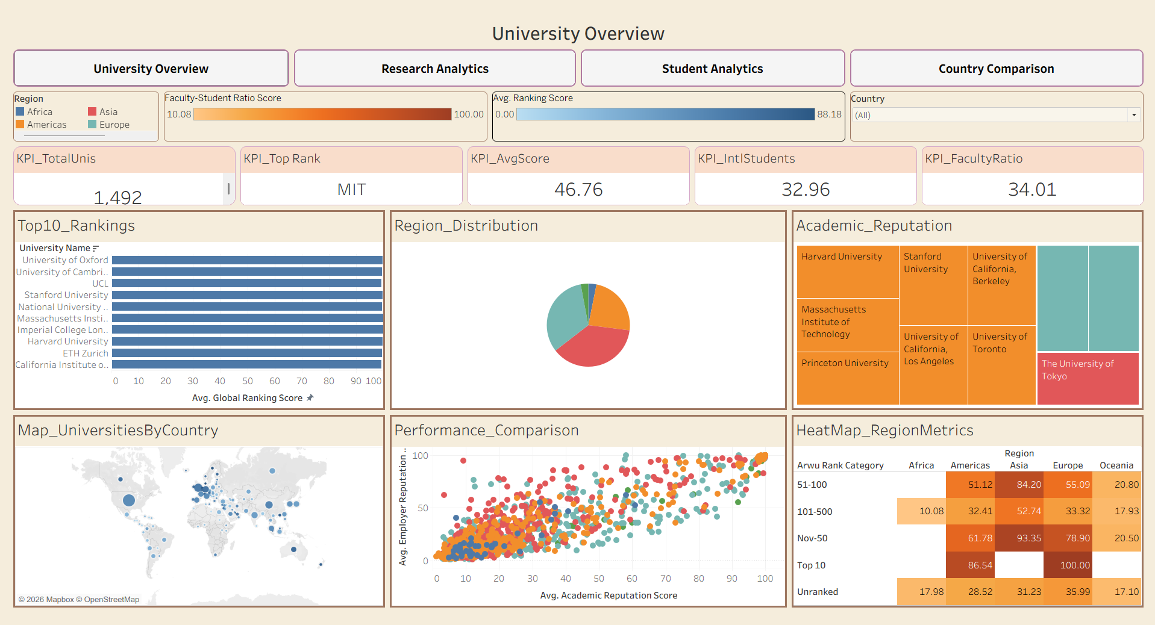
Figure 1 — The University Overview dashboard.

KPI Summary Cards
KPI_TotalUnis | 1,492 — total number of ranked institutions in the dataset
KPI_Top Rank | MIT — the single highest-ranked university in the current filter context
KPI_AvgScore | 46.76 — average Global Ranking Score across all institutions
KPI_IntlStudents | 32.96 — average International Student Percentage Score
KPI_FacultyRatio | 34.01 — average Faculty-to-Student Ratio Score

Visuals on This Dashboard
- Top10_Rankings — a horizontal bar chart of the ten highest-ranked universities by Avg. Global Ranking Score, led by Oxford, Cambridge, and UCL in this view
- Region_Distribution — a pie chart showing the share of ranked universities held by each world region
- Academic_Reputation — a treemap sized by Academic Reputation Score, surfacing institutions such as Harvard, Stanford, UC Berkeley, and MIT as the largest tiles
- Map_UniversitiesByCountry — a proportional-symbol world map showing where ranked institutions are concentrated geographically
- Performance_Comparison — a scatter plot of Avg. Academic Reputation Score against Avg. Employer Reputation Score, colour-coded by region, used to spot institutions that are strong on one dimension but not the other
- HeatMap_RegionMetrics — a cross-tab heat map of average Global Ranking Score by ARWU rank category (Top 10, Nov-50, 51-100, 101-500, Unranked) against region

What This Dashboard Answers
This dashboard answers the question "how is the global higher-education landscape shaped overall?" — which regions and countries host the most ranked institutions, which universities sit at the very top, and how reputation and geography relate to one another before drilling into research or student-level detail on the other three tabs.
- The dashboard is sequenced as a funnel, not a random grid. Reading it in intended order — Top10_Rankings → Region_Distribution/Map → Academic_Reputation → Performance_Comparison/HeatMap — mirrors how a first-time visitor actually explores unfamiliar data: start with recognizable names, then place them geographically, then start asking harder comparative questions. If you jump straight to the heat map without reading the leaderboard first, the region/category cells feel abstract; read in order, they feel like a natural drill-down.
- Shared colour-coding turns three separate charts into one argument. Region_Distribution, the map, and Performance_Comparison all use the same region colours, so a large wedge in the pie chart should, if reputation and volume are correlated, also show up as a dense cluster of same-coloured points in the scatter plot. When it doesn't — when a region has many institutions but few of them land in the upper-right (high academic and high employer reputation) — that's a meaningful disconnect: volume without proportional quality.
- Academic_Reputation as a treemap, not a bar chart, is itself an insight-shaping choice. Because reputation scores compress near the top of the 0–100 scale for elite institutions, a bar chart would show a wall of near-identical bars. The treemap's area-based sizing exaggerates small differences, which is exactly what's needed to distinguish "very elite" from "extremely elite" — the distinction a bar chart would flatten out.

7. Dashboard — Research Analytics
The Research Analytics dashboard focuses on the research side of the six KPIs — the Research Impact Score and the calculated Research Productivity Index — and lets a viewer isolate research strength independently of overall ranking or student profile. It is filterable by Region and by an ARWU Publications Score range slider.
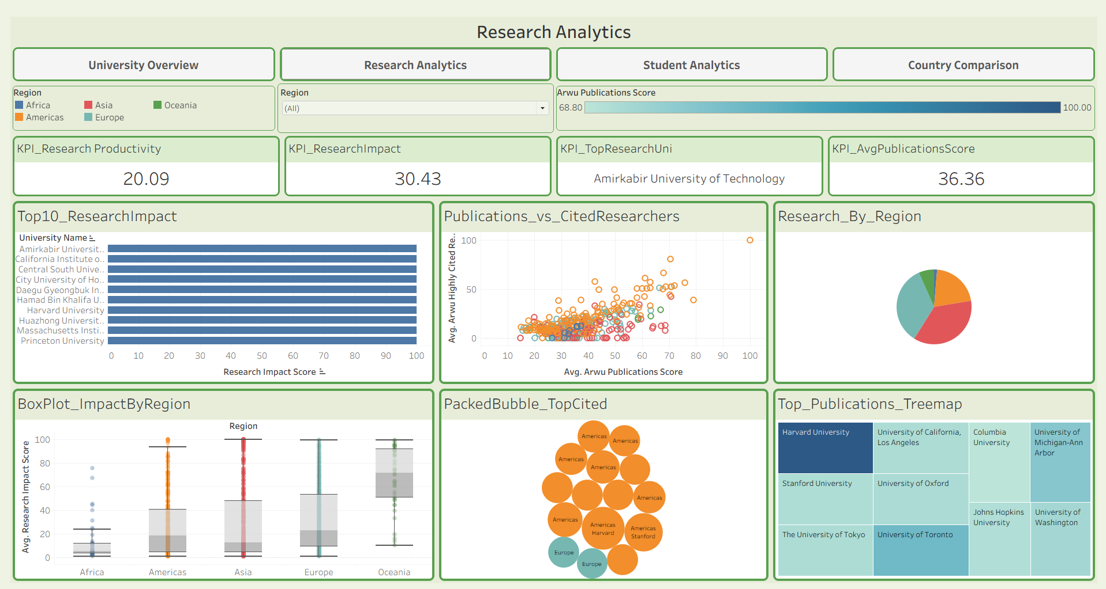
Figure 2 — The Research Analytics dashboard.

KPI Summary Cards
KPI_Research Productivity | 20.09 — average Research Productivity Index (mean of the 3 ARWU sub-scores)
KPI_ResearchImpact | 30.43 — average Research Impact Score (QS Citations-per-Faculty)
KPI_TopResearchUni | Amirkabir University of Technology — the top institution by Research Impact Score
KPI_AvgPublicationsScore | 36.36 — average ARWU Publications Score

Visuals on This Dashboard
- Top10_ResearchImpact — a bar chart ranking the ten universities with the highest Research Impact Score, led by Amirkabir University of Technology and Harvard University
- Publications_vs_CitedResearchers — a scatter plot of Avg. ARWU Publications Score against Avg. ARWU Highly Cited Researchers Score, showing whether high-volume research output also carries a high concentration of highly-cited faculty
- Research_By_Region — a pie chart of research output share by region
- BoxPlot_ImpactByRegion — a box-and-jitter plot comparing the spread and outliers of Research Impact Score within Africa, Americas, Asia, Europe, and Oceania
- PackedBubble_TopCited — a packed-bubble chart of the most highly-cited institutions, sized by citation impact and coloured by region (dominated by Americas institutions in this view)
- Top_Publications_Treemap — a treemap of the leading institutions by publication volume, including Harvard, Stanford, Columbia, and the University of Oxford

What This Dashboard Answers
This dashboard answers "which institutions and regions are driving global research output and impact?" — useful for researchers and administrators who want to benchmark research productivity independently of an institution's overall QS/ARWU rank or student profile.
- The dashboard's real question is "does volume equal influence?" — and it's built to let you falsify the naive answer. It would be easy to assume more publications automatically means more research impact. Publications_vs_CitedResearchers is placed specifically to test that: any institution that's high on the x-axis (Publications Score) but low on the y-axis (Highly Cited Researchers) is a volume leader without proportional influence, and that pattern is common enough in the scatter that it's worth actively looking for rather than assuming away.
- Top10_ResearchImpact deliberately does NOT match the overall ranking leaderboard, and that gap is the point. Research Impact Score measures citations-per-faculty, a ratio, not a raw count — so a smaller, highly specialized institution can outrank a larger, more famous one here. Seeing Amirkabir University of Technology lead over more globally recognized names is a direct demonstration that "famous" and "research-influential-per-capita" are different rankings, which is exactly the distinction this dashboard exists to surface.
- BoxPlot_ImpactByRegion answers a fairness question the bar charts can't. A regional average can hide huge internal variation. A region with a tall box and long whiskers (wide spread) has a few research powerhouses dragging up an average that most of its institutions don't come close to — meaning a claim like "Region X is strong in research" is only true for a minority of its universities. A region with a short, tight box is telling a more honest, uniform story. Reading this chart before trusting any regional average elsewhere on the dashboard prevents an overgeneralization.

8. Dashboard — Student Analytics
The Student Analytics dashboard shifts the focus from research to the student and faculty experience — international diversity, faculty ratios, and how those relate to employment outcomes after graduation. It is filterable by Region and Country, with an International Faculty Score range slider.
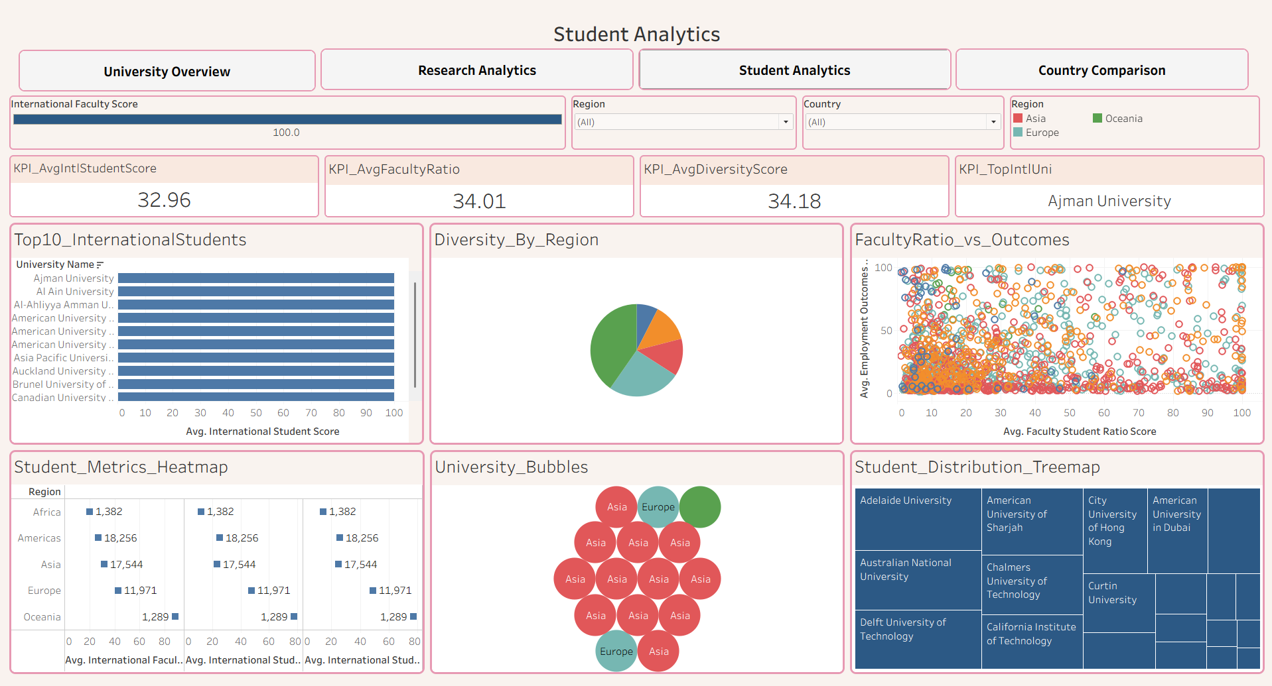
Figure 3 — The Student Analytics dashboard.

KPI Summary Cards
KPI_AvgIntlStudentScore | 32.96 — average International Student Percentage Score
KPI_AvgFacultyRatio | 34.01 — average Faculty-to-Student Ratio Score
KPI_AvgDiversityScore | 34.18 — average International Student Diversity Score
KPI_TopIntlUni | Ajman University — the top institution by International Student Score

Visuals on This Dashboard
- Top10_InternationalStudents — a bar chart of the ten universities with the highest International Student Score, led by Ajman University and Al Ain University
- Diversity_By_Region — a pie chart of average diversity score contribution by region
- FacultyRatio_vs_Outcomes — a scatter plot of Avg. Faculty Student Ratio Score against Avg. Employment Outcomes Score, used to test whether smaller class sizes correlate with stronger graduate outcomes
- Student_Metrics_Heatmap — a heat map combining International Faculty, International Student, and diversity scores by region
- University_Bubbles — a packed-bubble chart of institutions coloured by region, dominated by Asia-region universities in the current filter
- Student_Distribution_Treemap — a treemap of institutions such as Adelaide University, the American University of Sharjah, and Delft University of Technology, sized by a student-distribution metric

What This Dashboard Answers
This dashboard answers "how diverse and well-resourced is the student experience at each institution, and does that relate to post-graduation outcomes?" — of particular interest to prospective students and administrators focused on internationalization strategy.
- The absence of a trend in FacultyRatio_vs_Outcomes is the single most important finding on this dashboard, and it's easy to miss if you expect a clean story. The intuitive hypothesis — smaller class sizes (higher faculty ratio score) lead to better employment outcomes — is not supported by a visible diagonal pattern in the scatter. Points are scattered broadly across the full range on both axes. That's not a failed chart; it's a real signal that employment outcomes are driven by something this dashboard doesn't capture — likely country-level labour market conditions, which live on the Country Comparison dashboard, not here. The design intentionally leaves that gap open rather than forcing a false correlation.

- The leaderboard divergence from the other dashboards is deliberate and worth stating explicitly. Top10_InternationalStudents is dominated by institutions in international-hub countries (UAE, similar markets) rather than the globally famous names that top University Overview or the research specialists that top Research Analytics. If a viewer expects overlap and doesn't see it, that's not an inconsistency in the data — it's proof that "high international student percentage" measures something genuinely different from "high overall rank" or "high research output." Each dashboard is intentionally answering a different question with a different leaderboard.

- Student_Metrics_Heatmap rewards row-wise reading over cell-by-cell reading. Because it lays International Faculty, International Student, and Diversity scores side by side per region, the more useful read is comparing across the row for one region (is this region internationalized across all three dimensions, or strong on just one?) rather than scanning down a single column across regions.

9. Dashboard — Country Comparison
The Country Comparison dashboard rolls every KPI up from the institution level to the country level, making it the primary benchmarking tool for policymakers and consultants who need to compare national higher-education systems rather than individual universities. It is filterable by Country and Region, with Research Impact Score and Measure Values range sliders.
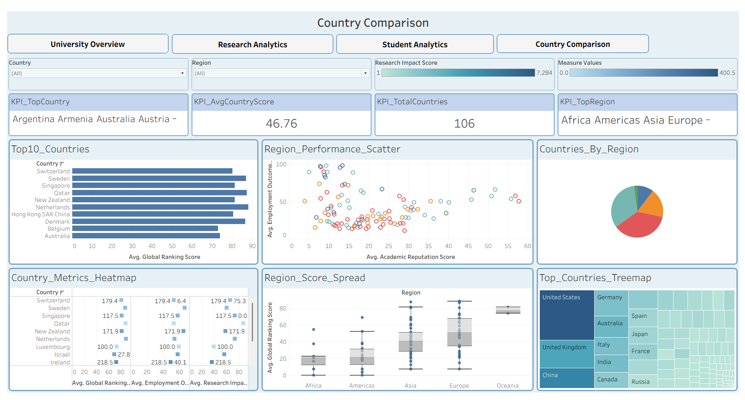
Figure 4 — The Country Comparison dashboard.

KPI Summary Cards
KPI_TopCountry | Argentina, Armenia, Australia, Austria… — countries tied at the top of the current ranking measure
KPI_AvgCountryScore | 46.76 — average Global Ranking Score across all 106 countries
KPI_TotalCountries | 106 — total number of countries represented in the dataset
KPI_TopRegion | Africa, Americas, Asia, Europe… — regions shown in the current filter context

Visuals on This Dashboard
- Top10_Countries — a bar chart of the ten highest-scoring countries by Avg. Global Ranking Score, led by Switzerland, Sweden, and Singapore
- Region_Performance_Scatter — a scatter plot of Avg. Academic Reputation Score against Avg. Employment Outcomes Score, coloured by region, used to spot standout national systems
- Countries_By_Region — a pie chart of the number of ranked countries contributed by each region
- Country_Metrics_Heatmap — a combined heat map / dot chart of Global Ranking, Employment Outcomes, and Research Impact scores per country
- Region_Score_Spread — a box-and-jitter plot comparing the distribution of Global Ranking Score across Africa, Americas, Asia, Europe, and Oceania, showing Asia and Europe with the widest spread
- Top_Countries_Treemap — a treemap of countries by ranked-university count, led by the United States, United Kingdom, and China

What This Dashboard Answers
This dashboard answers "which countries have the strongest higher-education systems overall, and how consistent is performance within each region?" — the primary view for national-level benchmarking and policy discussion.
- Two competing definitions of "strong country" are placed side by side on purpose, and they will disagree. Top10_Countries averages scores per country, so a country with one elite university and a handful of weaker ones can outrank a country with fifteen solid-but-not-spectacular universities. Top_Countries_Treemap does the opposite — it rewards raw volume of ranked institutions, which is why the US, UK, and China lead there but might not top the average-based bar chart. Neither metric is "more correct"; the dashboard is built so a viewer has to notice the tension and decide which definition of national strength matters for their question, rather than being handed a single verdict.

- Region_Score_Spread is a guardrail against overgeneralizing from Top10_Countries. If you see a country from Asia or Europe topping the leaderboard, Region_Score_Spread tells you whether that's representative — both regions show the widest spread in the dataset, meaning their best country is not a good proxy for the region as a whole. A narrower-spread region, by contrast, makes a regional claim much safer to generalize. This chart exists specifically to be checked before making any "Region X is strong" statement based on the bar chart alone.

- Country_Metrics_Heatmap is the dashboard's cross-check mechanism. Because it puts Global Ranking, Employment Outcomes, and Research Impact in the same row per country, it's the fastest way to spot a country that looks strong on one national metric but is quietly weak on another — a pattern a policymaker needs to know before citing a single flattering statistic in a briefing. Without this chart, spotting that kind of imbalance would require manually cross-referencing the other three dashboards.

- Countries_By_Region is a small but important denominator check. A region's strong showing in the other charts can be inflated simply by having more countries represented. Checking Countries_By_Region first tells a viewer whether a region's apparent dominance is genuine per-country strength or just a larger sample size — the same logic as checking sample size before trusting an average anywhere else.

10. Evaluation Criteria & Tech Stack

10.1 Evaluation Criteria
Milestone | Focus Area | Metric | Target
1 | Data Collection & Cleaning | Dataset Completeness | > 95% complete
2 | KPI Engineering | KPI Accuracy | 6+ KPIs generated
3 | Dashboard Development | Dashboard Functionality | 4 dashboards integrated
4 | Documentation & Delivery | Project Quality | Portfolio ready

10.2 Tech Stack
Area | Tools / Libraries
Data Collection | Python, QS Rankings, ARWU / World University Rankings
Data Processing | Pandas, NumPy
Data Cleaning | Python (Jupyter Notebook)
Visualization | Tableau Desktop / Tableau Public
Dashboard Integration | Tableau Filters, Parameters, Actions
Documentation | Markdown, GitHub

11. Deliverables Summary
The table below consolidates every deliverable produced across the four project milestones, matching the outputs found in the uploaded project files.
Milestone | Deliverable | Description
1 | university_raw_data.csv | Merged QS + ARWU raw dataset (1,501 institutions)
1 | data_collection.py | Script used to collect and merge the raw ranking datasets
2 | university_cleaned.csv | Cleaned, standardized, Tableau-ready dataset (1,492 rows)
2 | education_cleaning.ipynb | Step-by-step data cleaning & transformation notebook
3 | generate_education_kpis.py | KPI engineering script — validates 5 KPIs, calculates the 6th
3 | university_final_dataset.xlsx | Final Tableau data source with all six KPIs
4 | dashboard_storyboard.pdf / eduvision_prototype.twbx | Dashboard wireframes and interactive prototype
4 | eduvision_dashboard_v1.twbx | First integrated build of all four dashboards
4 | EduVision_DV.twbx | Final, fully integrated Tableau workbook

12. Conclusion
EduVision DV delivers on its original project statement: raw QS and ARWU ranking data has been collected, merged, cleaned to better than 95% completeness, and transformed into six standardized education KPIs on a common 0–100 scale. Those KPIs power four interconnected Tableau dashboards — University Overview, Research Analytics, Student Analytics, and Country Comparison — each addressing a distinct audience need, from institution-level exploration to national benchmarking.
The resulting workbook, EduVision_DV.twbx, is a portfolio-ready deliverable that demonstrates the full analytics pipeline end to end: data engineering, KPI design, and interactive dashboard development, all documented and validated against the evaluation criteria defined at project kickoff.

13. Appendix A — Data Cleaning Operations Log
Summarized from education_cleaning.ipynb:
- Standardized column names to snake_case (e.g. "AR SCORE" → academic_reputation_score)
- Cleaned institution name field (removed parenthetical abbreviations, e.g. "(MIT)")
- Removed duplicate institution records
- Converted text-based rank fields (handling tie symbols like "7=") into clean numeric rank columns for both QS and ARWU
- Deliberately preserved nulls in ARWU rank where an institution is legitimately unranked, rather than imputing a value
- Created ranking-band categories (Top 10, Nov-50, 51-100, 101-500, Unranked) for both systems
- Computed rank difference and absolute rank difference between QS and ARWU to flag divergence between the two systems
- Standardized country names for consistent geographic joins/mapping
- Final validation pass confirming <2% missing values across fields used for KPIs and dashboard visuals

Appendix B — Evaluation Criteria & Tech Stack
Evaluation Criteria
Milestone | Focus Area | Metric | Target
1 | Data Collection & Cleaning | Dataset Completeness | >95% complete
2 | KPI Engineering | KPI Accuracy | 6+ KPIs generated
3 | Dashboard Development | Dashboard Functionality | 4 dashboards integrated
4 | Documentation & Delivery | Project Quality | Portfolio ready
Tech Stack
Area | Tools / Libraries
Data Collection | Python, QS Rankings, ARWU / World University Rankings
Data Processing | Pandas, NumPy
Data Cleaning | Python (Jupyter Notebook)
Visualization | Tableau Desktop / Tableau Public
Dashboard Integration | Tableau Filters, Parameters, Actions
Documentation | Markdown, GitHub

